**Data: 07-Dec-16 Name: Vieriu Denis-Gabriel**

**Group: 915**

Computational logic

Optional homework – implementation operations + conversions

# Subalgorithm’s diagram

**Controller module : UI module:**

additionUI()

substractionUI()

divisionUI()

multiplicationUI()

mulUI()

substitutionMethodUI()

successiveDivisionUI()

convertFromBaseToAnotherUI()

………………………….

addition()

substraction()

division()

multiplication()

mul()

substitutionMethod()

successiveDivision()

convertFromBaseToAnother()

………………………….

/?

# Problem statment

**The application must implement algorithms for:**

* + arithmetic operations: addition, subtraction, multiplication and division by one digit, in a base p∈{2,3,...,9,10,16}
  + conversions of natural numbers between two bases p,q∈{2,3,...,9,10,16} using the substitution method or successive divisions and rapid conversions between two bases p,q∈{2, 4, 8, 16}.

and must have a menu such that all operations and conversion methods to be verified separately.

**The following algorithms are implemented:**

- algorithm for the method of successive divisions

- algorithm for the substitution method

- algorithm for conversion using 10 as an intermediate base

- rapid conversions between two bases p,q∈{2, 4, 8, 16}.

- addition of two numbers in a base

- subtraction of two numbers in a base

- multiplication of a number by a digit in a base

- division of a number by a digit in a base

# Used data type specifications

The **language** used for solving the problem: **python** (3.6)

**IDLE** used: **eclipse** with **pydev**

**Data types used:**

* **list**

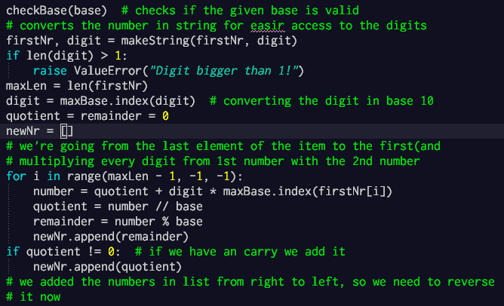

**newNr** is initialized with an empty list in which we will remember characters

* **int**
* **str** (to transform int to str)



**Integer**

**String**



# Data test

A set of data test is already implemented in the program, in a separated module for easier access to it:

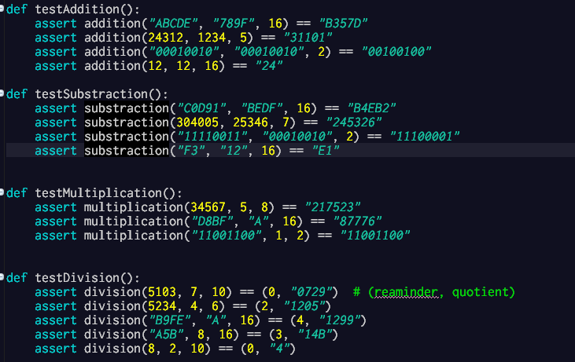

* Also it has implemented function to run all tests which will be found at **startApp**.

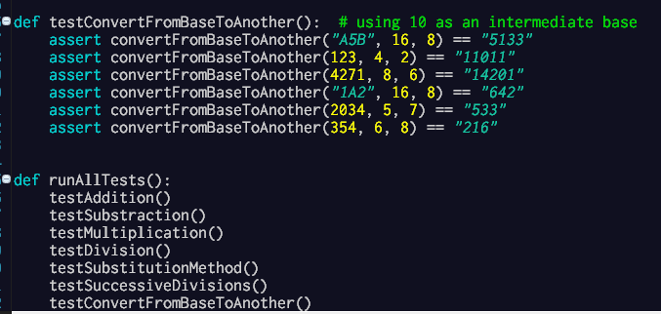

# Specification and pseudocode

**Python** is already an program very **easy to read** and the **pseudocode** would looks almost like the language, the specification are found all over the controller for easier understanding of the program, here are some examples:

* Here is the **addition** algorithm:

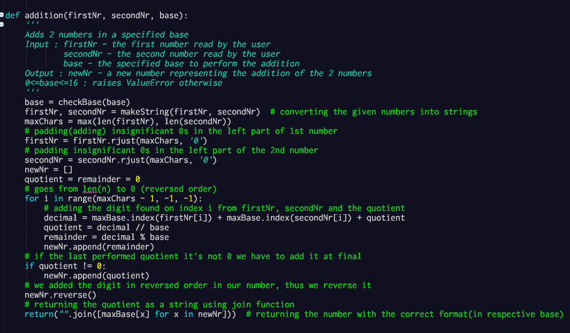

Specification

* Here is a **function** that tests if a number is **power of a base** using **logarithm**

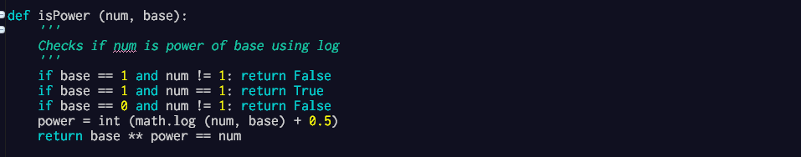

* **Multiplication** algorithm:

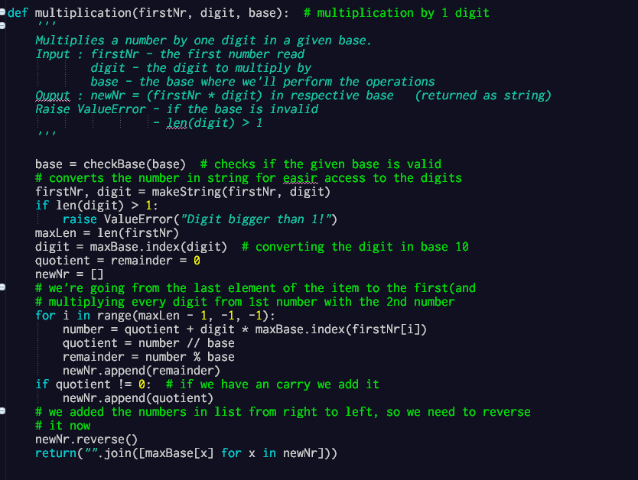

Output data

Input data

**Running scenario for addition Note: the menu will appear at startApp runtime**

|  |  |  |  |
| --- | --- | --- | --- |
|  | User | Program | Description |
| 1 | 1 |  | **User** enters 1 |
| 2 |  | Enter first number: |  |
| 3 | ABCDE |  | **Saves** the first number in a variable |
| 4 |  | Enter second number: |  |
| 5 | 789F |  | **Saves** the second number in a variable |
| 6 |  | Enter the base of the 2 numbers: |  |
| 7 | 16 |  | **Saves** base in a variable |
| 8 |  | B357D | **Shows** the addition of the 2 numbers |